DRAGON TIPS & TRICKS
Enhancing Dictation

DRAGON FACTS
- By design Dragons Optimum Accuracy Rate is 90%
- 80%-90% (Above Average User)
- 60-75% (Average User)
- 40- 60% (Occasional)
- Less than 40% (Infrequent)

AGENDA
- Accuracy Center to Optimize Dictation
- Volume Check & Quality Check
- Program Dragon Mic Buttons
- Create Voice Command to log you into PowerChart
- Go over preloaded voice activated commands
- Review where to get Dragon help

COURSE INSTRUCTION
ACCURACY TUNING
  - TOOLS → ACCURACY → CHECK YOUR AUDIO SETTINGS
Volume Check Window
- Instruct providers that they will click “Start Volume Check” and read the paragraph that becomes bold in the box until they hear a beep to signal check is complete and box displays:
Quality Check Window
  - click “Start Quality Check” and read the paragraph
  - click “next” when completed and status displays “PASSED”

DICTATION TIPS
  - Tips on Dictation and Refining for more accurate dictation
  - Speak using multiple word entries
  - MIC 4”- 6” from mouth, off center
  - Enunciate (try not to drop T’s, S’s, N’s
  - MAKE CORRECTIONS THROUGH DRAGON

PROGRAMMING MIC BUTTONS

PowerMic II Configuration
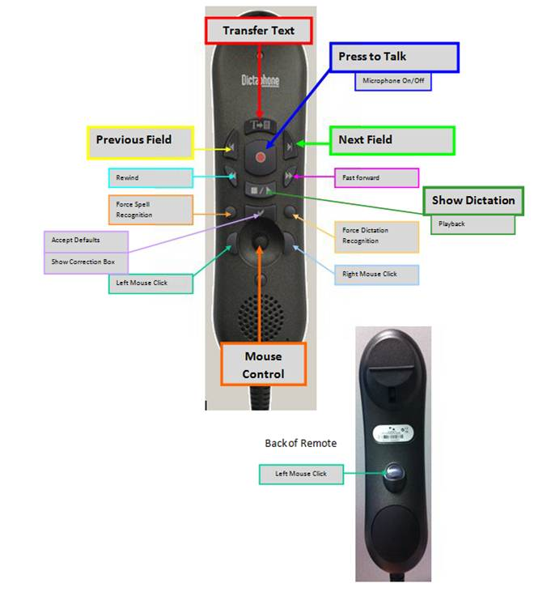

Mic Buttons can be programmed to represent a specific voice command

- Go to Dragon Bar → Tools → Options → PowerMic II Tab
- Determine Button you wish to be a command (the Rewind Button)
- Go to the corresponding Application name a drop down box
- Select “User Commands”
- Select from available list OR type delete
- Click “Apply: → Click “OK”
- Open Dictation Box

SETTING UP VOICE COMMAND TO OPEN POWERCHART

- Dragon Bar:
→Click “TOOLS”
→Click “COMMAND BROWSER”
→Click “ACUTE” folder
→Highlight “Canopy Log In” and right click
→Select “Edit” (Commands Editor window will open)

- Default command is Canopy Log In; Provider can rename (Ex: Open Sesame, Open Power, etc…..)
→Enter command name in “My Command Name Box”
- Go to Steps Box
→Highlight 7th line “Type User Name” → Click “Edit” → Enter your User ID
→Highlight 9th line “Type Your Password” → Click “Edit” → Enter your password

- Save → Close Editor Box

- Test the open PowerChart command you just created.

REVIEWING AVAILABLE VOICE ACTIVATED ACTION COMMANDS
Under the “All” folder in the Command Browser the is a list of verbal commands that interface with Canopy Apps
DRAGON HELP
- To do General Training Readings: Go to Dragon Bar → Select “Accuracy” → Select “General Training”→ Select Reading → click “OK”

- WBT’s
People Connect: Education → Canopy Education → Select “Dragon- Tips” on menu on the left
Outside CHS: http://physicianconnect.carolinas.org

QUESTIONS

