Dragon – Recommended Preference Settings
Following is a series of screenshots that show the recommended settings for Dragon. Many of the default settings are recommended, but those that are not will be noted under the corresponding image.
- From the main dragon toolbar select Tools → Formatting
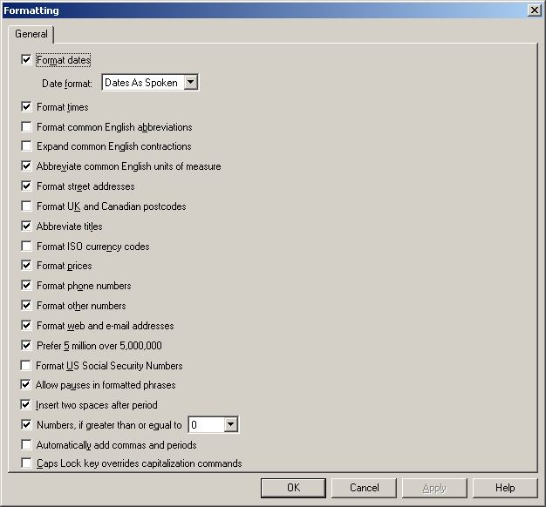
Typically not defaulted:
- “Automatically add commas and periods”. Recommendation is to uncheck that box.

- From the main dragon toolbar select Tools → Options → View
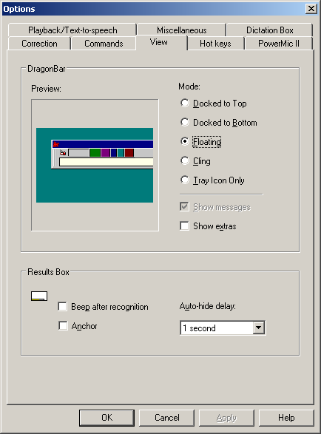
Typically not defaulted:
- Dragon bar mode – No standard recommendation, user preference.
- Auto-hide delay – Recommendation is 1 or 2 seconds.

- From the main dragon toolbar select Tools → Options → PowerMic II
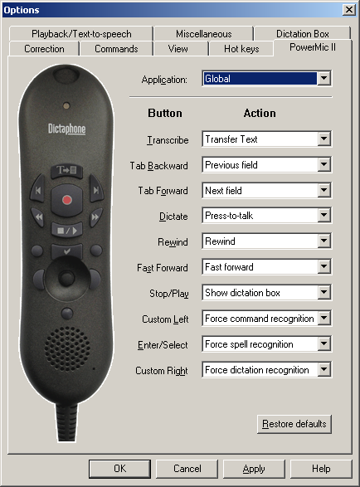
Typically not defaulted:
- Transcribe Button – Recommendation is Dictation → “Transfer Text”.
- Dictate Button – Recommendation is Dictation → “Press-to-talk”.
- Stop/Play Button – Recommendation is Applications → “Show dictation box”.
- Enter/Select Button – Recommendation is Recognition Modes → “Force spell recognition”.
- From the main dragon toolbar select Tools → Options → Miscellaneous
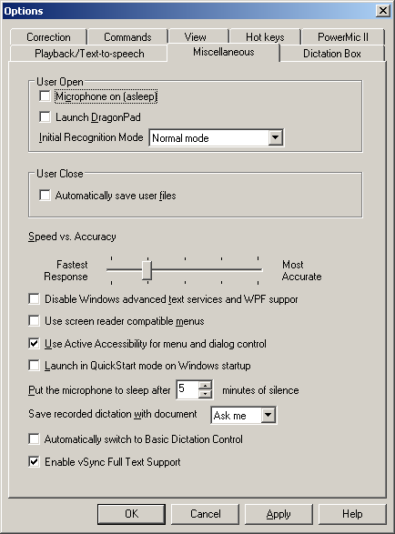
Typically not defaulted:
- Speed vs. Accuracy – Start with slider as far right (towards “Most Accurate”) as is comfortable, and move the setting incrementally left (Towards “Fastest Response”). Make an incremental shift only after you have had several shift-long sessions during which the accuracy was completely satisfactory.
- Should not have “Automatically save user files” selected. This allows user to choose not to save user files if ambient noise is too loud or user is congested and voice is altered.

- From the main dragon toolbar select Tools → Options → Dictation Box
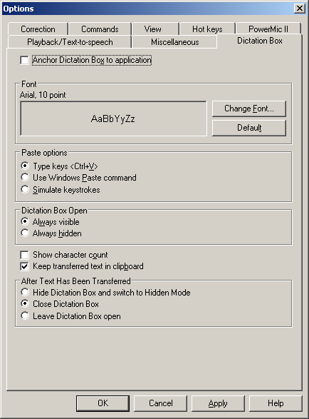
Typically not defaulted:
- Font – Recommendation is Arial, 10pt. This will match the font of PowerNote.
- Paste Options – Recommendation is to set this as “Type Keys <Ctrl+V>”.
- Keep transferred text in clipboard – Recommendation is to check this box.

